Inland Leaders
2020-2021 School Year Opening & Safety Plan
(District Guide)

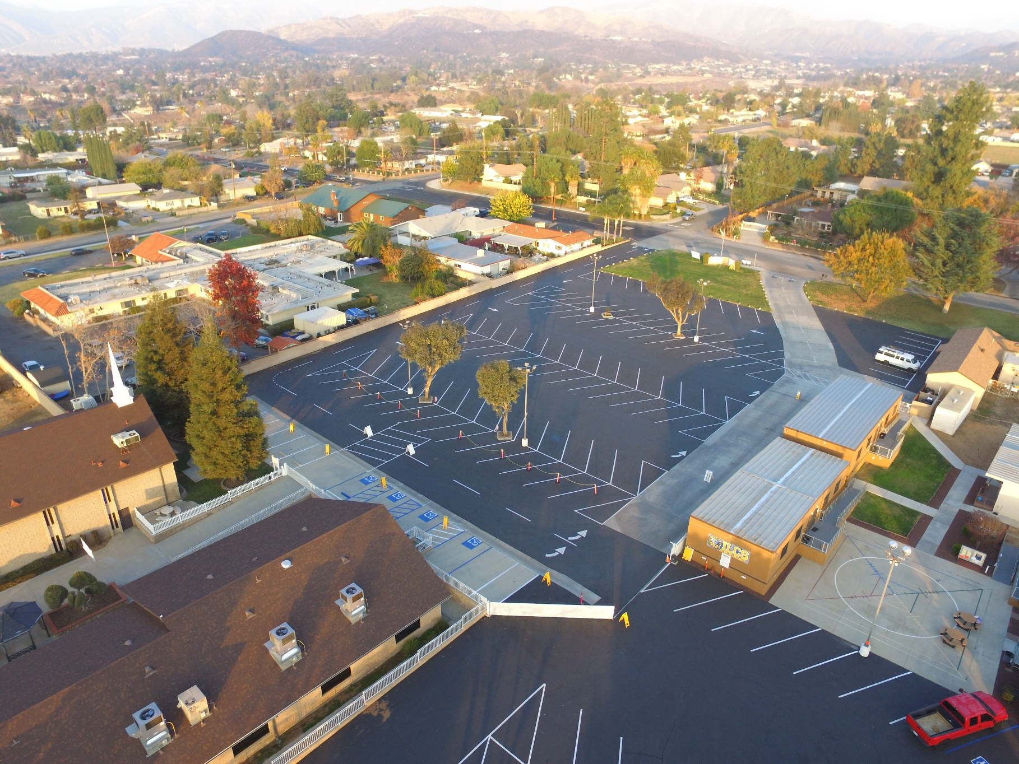

This document represents the overall ILCS program guide. Specific school site documents are also available.
This document is subject to change when state and county regulations require new additions and amendments.

August 2020
Amended 9-10-2020

TABLE OF CONTENTS
1
A M E S S A G E F R O M M R. G O R D O N

2
W H A T T O E X P E C T

3
H E A L T H & S A F E T Y

5
C O V I D - 1 9 R E P O R T I N G

6
C O V I D - 1 9 F A Q S

9
S C H O O L D E C I S I O N T R E E

1 0
O N C A M P U S A N D I N T H E
C L A S S R O O M

1 1
E D U C A T I O N A L O P T I O NS

1 5
S P E C I A L E D U C A T I O N

1 6
M E N T A L W E L L N E S S

1 7
E X T R A C U R R I C U L A R A C T I V I T I E S

18
A D D I T I O N A L R E S O U R C E S

A MESSAGE FROM MIKE GORDON
Dear ILCS families and staff,
As we prepare for the new year, I was ready to deliver our new “Thrive in 25” vision that would guide us for the next five years to the 2025 school year. This vision involves our new programs and innovations to increase student learning and leadership skills. At one point I thought “Survive to 2025” was more appropriate, but I quickly remembered that ILCS “thrives” on challenges and looks at the current crisis as a unique opportunity to innovate and evolve into a better school than previously imagined.
This coming school year presents the greatest challenge we have faced to date. In response, we collected parent and staff opinions on extensive surveys in preparation for the new year and as a school of choice, we have developed the following plans based on the majority of responses and the “choices” requested. This document reflects overall general strategies and procedures for our schools. CSC and BSC sites will be providing even more detailed information to families regarding processes prior to the first day of school.
I recognize that not every family will be completely satisfied with our new procedures and educational program designs, but I believe we have made a great step forward in providing a safe and effective learning program whether you are on campus or a distance learner. Please understand that this guide presents our desire to prevent and mitigate the spread of the virus, but there will always be risk of infection of any virus when more than one person is present. Therefore, this guide will provide the actions we are taking at our sites so that you can make an informed choice in regards to whether your students attend ILCS.
Please understand that our procedures may need to be altered or changed based on the orders and directives of our county health department and/or the state agencies that oversee our programs. In the event certain classes or even the whole school is required to close, we will initiate our 100% distance learning program, where students work completely from home. With your support and everyone’s diligence to keep our students safe, it is my hope and prayer that our school will be open for the majority of the school year and that we will continue to go “beyond the limits” for student success.

Your partner in education,

Mike Gordon
Director/ Founder

What to Expect when School Returns

The health and safety of our students, staff, and families is of utmost importance. When the 2020-2021 school year begins, our schools will look different than previous years due to new health and safety measures. This plan to reopen schools is based on current guidance from public health officials and state agencies along with our families’ input. These guidelines will be updated as the situation evolves. ILCS has determined that the best way to prevent the spread of illness is to “self-contain” our students so that they only interact with their own class throughout the school day, including middle school students. We recognize that at the time of this document release, schools have been mandated to stay physically closed, but ILCS believes that we need to be ready to re-open as soon as possible and that careful planning will gets us back to school sooner. The Executive Director along with the Board of Directors is responsible for assuring that safety plans and protocols are followed.

It is important to note that our plans must focus on academic instruction to ensure student academic gains and address learning loss. We will continue to monitor and determine whether extra-curricular activities such as electives and sports are safe enough to implement based on guidance from the California Interscholastic Federation (CIF) and California Department of Public Health (CDPH). At this time, we do not plan on the extra-curricular activities to begin as we start the 2020 school year.

As students return, it will look different.
Screening at Home | Arriving at School
- Families are recommended to take temperatures daily before going to school. Anyone with a fever of 100.4 F or higher should not go to a school site. Personal illness, quarantine, and COVID-19 illness or symptom related absences will be excused.  - Students and adults are recommended to self-screen through ParentSquare for respiratory symptoms such as cough and shortness of breath prior to coming to school each day. Students and adults experiencing those symptoms should not attend school.  - Staff members are required to self-screen and complete a daily temperature check prior to coming to work. If staff members are experiencing symptoms, they should stay home and contact the Administration. | - Face coverings are required for students and staff members  - Parents and visitors will have limited access to the school campus.  - Students will take part in recess/breaks in their “cohorts” only.  - School sites will designate routes for entry and exit in order to limit direct contact with others.  - Student temperatures will be taken upon entry to the school at the entrance gates. Students with temps at 100.4 or above will be sent to the health station for further screening and sent home if symptoms exist.  - School sites will have signage throughout campus to remind students and staff about social distancing, hand washing, and proper hygiene.  - Thorough cleaning, sanitation and disinfecting throughout the schools

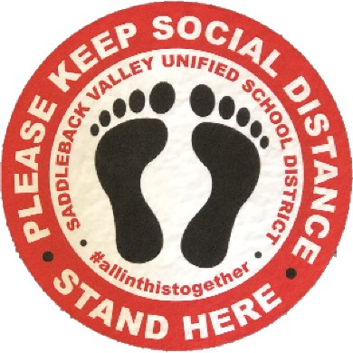

Minimizing Infection/ Sanitation/ Disinfecting

Health & Safety Protocols Summary

- Common touch surfaces will be cleaned regularly (e.g. countertops, door handles, restrooms, student desks, student chairs, etc.).
- Staff and students will be expected to wash/sanitize their hands regularly.
- Every classroom will be provided with hand sanitizer stations.
- New hand washing stations installed for use at each campus.
  - A plan in place to minimize lines of students and how often students will wash hands (upon entry and after each class break)
- Schools will limit sharing of supplies between students by assigning individual equipment and materials.
- Protexus used on rooms once a day- A disinfecting and sanitizing tool/sprayer designed to kill viruses.
- Signage will promote healthy hygiene practices and reminders to stay home when ill.
- Students will be encouraged to bring refillable water bottles from home.
- Playground equipment will be regularly inspected and cleaned for student use.
- Shared computers in the labs will be sanitized after every period.
- Air purifiers in common staff and office areas.
- All students’ temperatures checked upon entry of school site.
- Students remain with the same cohort of students all day including during unstructured recess/break times.

Training Guidelines

- SafeSchools training for staff regarding COVID-19 before return to campus.
- School Nurse (RN) to provide COVID-19 training to staff on identifying signs and symptoms and response protocol.
- Students trained in hand hygiene, face coverings, social distancing and respiratory etiquette during the first day of school.
- Video for parents on the new “re-opening” plan prior to first day on campus.
- All staff required to receive OSHA mandated training through the CA Dept of Pesticide Regulation.
- Harassment/Bullying awareness for students in regards to COVID related issues.
- Increased awareness of hygiene and illness through campus posters.
- Campuses will follow guidelines developed by CDPH for cleaning, disinfection, and ventilation of school campuses.
- Staff COVID-19 guidelines to describe procedures in regards to preventing and responding to illness on campus.

Programs/Gatherings

- Back to School Night will be virtual.
- Students organized into class cohorts that do not mix with other cohorts.
- Assemblies/Award Ceremonies will be limited and/or virtual.
- Second Session (CSC); cancelled until further notice.
- Delay of Field Trips until further notice.
- Electives - cancelled until further notice.
- Athletics - to be determined by sport and risk level as directed by the league, CIF and CDPH
- Staggered entry and exit of classes so cohorts have minimal contact.

Face Covering and Personal Protective Equipment (PPE)
In accordance with the California Department of Public Health's (CDPH) Guidance for Face Coverings.
Students must utilize face coverings: While in the classroom
While waiting to enter campus
While on school grounds (except when eating or drinking)
While leaving school
Personal Protective Equipment (PPE) will be provided to staff and students.
Students and staff will be provided face masks and are expected to wear them daily.
Personal face coverings will be allowed in compliance with dress code policy.
Teachers and identified staff members will receive a reusable face shield. Gloves are not recommended for use by students or staff, with the exception of those conducting cleaning, first aid, or food service.
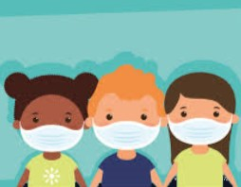

*Supply chain issues may prevent the use of certain products and equipment

On Campus and in the Classroom
6 FEET

Social distancing will limit the spread of the virus. Schools will do their best to:
Restrict non-essential visitors, volunteers, and activities involving other groups.
Limit group activities wherever practicable.
Arrange classroom space to remove non-essential furniture, allowing maximum space for students and staff.
Arrange student desks to face the same direction (rather than facing each other) and maintain physical distancing.
Designate routes for entry and exit during transition times, as feasible.

l
COVID Reporting

Staff and parents of students need to report exposures or confirmed positive COVID-19 test results to the San Bernardino County Department of Public Health (SBCDPH) by completing this survey. ILCS administration will also direct school stakeholders to complete the form whenever they suspect COVID-19 related issues. SBCDPH will follow-up with contacts that are identified in the survey.
Staff members, students and families need to follow CDC guidance to help prevent the spread of COVID-19. ILCS will utilize the San Bernardino County’s Guidance for Employers and the Community Regarding COVID-19 Infection and Exposure, which helps determine the steps to take when an employee (or a student) has been diagnosed with COVID-19 or has been exposed to a person diagnosed with COVID-19.
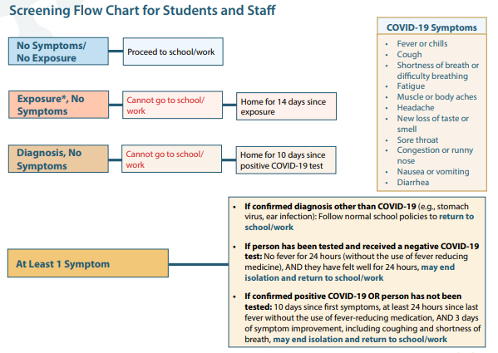

*Exposure refers to being within 6 feet of someone diagnosed with COVID-19 for 15 minutes or more.
CDC webpage on when you can return to school or work: https://www.cdc.gov/coronavirus/2019-ncov/if-you-are-sick/end-home-isolation.html
CONTACT TRACING
SBCDPH guidelines will be utilized to implement contract tracing at ILCS. Tracing will be performed by a team of comprised of the school nurse (Registered Nurse) and the health technicians at the sites. School staff will notify the individual with a potential case, interview the person, locate and notify contacts potentially exposed, and monitor contacts under SBCDPH guidance.

COVID-19 FAQ

What do I do if my child is experiencing COVID- 19 symptoms while at home?

If your child is experiencing COVID-19 symptoms, please keep them home and contact your child’s health care provider. Please contact your school to report the absence; a COVID-19 related absence is excused.
What if someone in our household tested positive for COVID- 19 ?

If someone in your household tested positive for COVID-19 and is currently under quarantine or self-isolation, your child should follow the guidelines from the CDC on how long to remain at home and when to return to school. https://www.cdc.gov/coronavirus/2019-ncov/if-you-are-sick/steps-when-sick.html
What happens if a student demonstrates COVID- 19 symptoms while at school?

If a student becomes ill during the school day, the following steps will be taken: Student will be taken to an isolation area where temperature and symptoms will be evaluated; student will remain in the isolation area until they are picked up by a parent or guardian.
The school site will work with the school nurse and response team to coordinate with County Health regarding the suspected case and all confirmed cases on site.
The school nurse coordinates the response to all possible and confirmed COVID-19 cases with County Health, who will assist ILCS in developing a course of action for a positive school or classroom dismissal for up to three days.

COVID-19 FAQ

What happens if a positive COVID-19 case occurs at a school site?

For any positive COVID-19 case the following protocol will be followed:
In accordance with state and local laws and regulations, school administrators will record the following information:
Name of person confirmed
If known, date of potential exposure Date of test
Last date on ILCS facility
Names of individuals who had physical contact with an infected person or spent 15 minutes or more within a six feet distance
The Administration will coordinate a response with County Health. After receiving direction from the County, administration will only notify students, staff, and families who have been potentially exposed to COVID-19 and provide health recommendations and guidance from the County.
A positive COVID-19 case may lead a classroom, multiple classrooms, or a school to return to distance learning for a period of time. Any closures will be determined by the administration after consultations with County Health.
The classroom or impacted areas will receive an extensive cleaning and sanitation following CDC guidelines.
How are others notified they were in contact with an individual who tested positive for COVID- 19 ?

ILCS works with County Health to determine close contacts and low risk contacts. Individuals identified by County Health are contacted via an email that outlines specifics regarding how long the individual must quarantine, steps to mitigate contracting the coronavirus, and list symptoms associated with the virus.
All HIPPA/FERPA notifications guidelines for privacy will always be followed.

COVID-19 FAQ

Employee Screenings

Employees must complete a self monitoring health screening before work. Employees who exhibit symptoms should remain at home and contact Human Resources at tduran@inlandleaders.com as well as the school nurse at nurse@inlandleaders.com
Employees must monitor themselves for these symptoms and stay home if they exhibit any:
Fever at or above 100.4
Chills or unexplained fatigue
Shortness of breath or difficulty breathing Sore throat
Cough
New loss of taste or smell Other flu-like symptoms
Employee Exposure or Confirmed Cases

ILCS monitors possible COVID-19 exposure and coordinates responses with County Health. After receiving direction from County Health, administration will only notify students, staff, and families who have been potentially exposed to COVID-19 and provide health recommendations and guidance from SBCPHD’ An employee who tests positive for COVID-19 or believes they have been exposed to a confirmed case of COVID-19 should contact their immediate supervisor. The school nurse will be the designated person to contact the SBCDPH regarding the case.
School Closure/ Distance Learning Trigger

In the event that 5% or more of the school population is identified as positive with COVID-19, the Executive Director in collaboration with the ILCS Board of Directors will close the school campus, initiate distance learning and communicate this change to all stakeholders through the ParentSquare notification system.

SCHOOL DECISION TREE

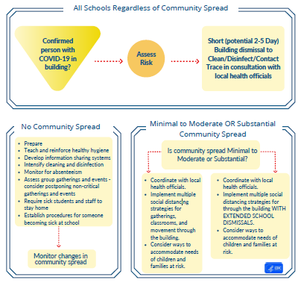

https://www.cdc.gov/coronavirus/2019-ncov/community/schools-childcare/guidance-for-schools.html

COVID-19 Protocols & Notification
County Health may take responsibility for clearance of individuals infected with COVID-19, including students. After a positive diagnosis is made, students are expected to be in isolation for at least 14 days after the test, and potentially longer if they continue to remain symptomatic.
Students may not return to school until they have been cleared by County Health. Health clerks and school nurse will work directly with families when they are cleared and ready to return to school.

On campus and in the classroom

- During the regular school hours, school sites will restrict non-essential visitors, volunteers, and activities involving other groups.
- Outdoor use of space for instruction will be encouraged
- Nutrition services will provide lunches in a “touchless” drive-by car line at each school site to eliminate student lunch lines. This may need to be amended based on federal nutrition guidelines.
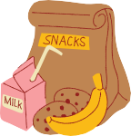
- All community organizations and groups that access the school facilities must adhere to the protocols listed in this document.

While in the Classroom:
- Students will stay in their own class with their teacher during instructional and break times
- Hand sanitizers in every classroom
- Students will clean their specific area with a safe FDA approved cleaner that can be used by children before leaving for breaks and before leaving to go home.
- Limit sharing of classroom supplies - no shared technology, no shared table supplies. Books that are shared will be sanitized.
- Desk barriers available for students upon request
- Classroom space will be arranged to remove non-essential furniture, allowing maximum space for students and staff.
- Implement multiple social distancing strategies for gatherings, classrooms, and movement through the school site along with floor signage and tape that marks a safe distance.

Outside of Class:
- Hand sanitizing (or handwashing) expected before eating, starting class, and leaving for the school day.
- New wash stations installed at each campus.
- Hand washing required upon return from PE, recess, and/or lunch.
- Lunches - No salad bar will be offered. Grab & Go” lunches will be served to eliminate students waiting in lunch lines.
- When lunch is allowed to be eaten on campus; multiple eating areas will be provided
- Student recess and PE times will be provided by “contained class” to prevent interactions of students in different classes.
- PE - PE coaches will keep social distancing in mind when planning activities and will disinfect materials and equipment regularly.
- Entrance and exit times will be staggered by grade level along with greater separation along our pick-up and drop off zones to promote more distance.

Educational Options

Quality instruction and a commitment to equity for all students continues to be a focus for ILCS education programs. We know the needs of our students and families vary which is why we have provided three instructional options for the 2020-2021 school year.

2020-2021 Instructional Programs
For the 2020-2021 academic year, ILCS will provide families with a choice of instructional options including:

- Traditional School
- Hybrid
- iSchool 2.0
- Independent Study

*ILCS may be required to implement 100% distance learning (iSchool) in the event the county health department or state requires closure.

Current seat based students - Students in our regular seat based program (5 days a week). Families who choose a different option this year such as i-School Hybrid or Full Time Independent Study will be guaranteed their student’s place in the regular school program for one school year. Students may apply to transfer to another program within ILCS before the end of each trimester/semester, including the return to the traditional program if needed.

*Please note Educational options may be altered to comply with state and local regulations.
Traditional  (Normal school day) | Hybrid  (Combination of site and online instruction) | iSchool 2.0  (school or class closure) | Full Time-Independent Study  (Homeschool)
- In-person instruction 5 days a week  - This mirrors our previously offered program  - Program day goes from 8am to approximately 1:30pm.  - Lunches provided as grab and go.  - City STARS program on campus for child-care after school. (CSC) | - In-person instruction during the week with at home instructional support. Student may be allowed to stay home more days depending on progress.  - Days of instruction or sessions at school will be assigned in coordination with parents  - Technology provided if needed for at home instruction  - See FAQS below | - 100% distance learning during school closures for site-based students.  - Live daily interaction with a teacher for math, ELA, Science/Soc Studies.  - Minimum of 240 instructional minutes a day. | - Full time learning at home with curriculum tailored to the student  - Teacher assigned as an advisor with meetings every 3 weeks  - Parent is the teacher at home

HYBRID FAQ

Q: What does the new Hybrid program at Inland Leaders look like?
A: Students will be assigned a grade level teacher and will come onto campus during the week for in-person instruction and will learn from home on the other days or times during the week. When at home hybrid students will watch live or recorded lessons from their teacher, utilize online resources for learning, interact with students in the site based program via the internet, and complete their assignments. Students who need extra support will be invited to attend specific in person sessions as well.

Q: How much support will a parent need to provide to their student for the hybrid program?
A: ILCS believes that every student progresses at different rates and this will depend on the student’s ability to work independently. Younger students typically require more support from their parents and teachers in general in order to progress in their learning. If you have a Kindergarten through 3rd grade student, you should plan on being available during the days the student is home to help support them in the event they need help or encouragement. Older students will need guidance, but may not need as much attention.

Q: If my student chooses the hybrid program, will they be able to return to the normal school day program in the future?
A: Yes, students who choose the hybrid program will have the opportunity to return to the normal school day program (once approved by the state/county) in the event that they are not making progress or if the program is not working well for them.

Q: Will the hybrid program be a part of the independent study program?
A: No, students in the hybrid program will not be considered as a part of independent study as the state has allowed for them to continue to be viewed as site-based students as long as they are participating and completing assignments on the days they are not at the site.

Q: When will we know who our teacher will be?
A: Hybrid teachers will be a combination of current teachers at ILCS and new teachers hired to help us build out the program. Some grade level hybrid programs will utilize a current ILCS teacher who will take all of the hybrid students for that grade along with normal day students to make a full class. Some grades will have a separate hybrid teacher who will be responsible for just the hybrid students who will alternate the days they attend.

Q: What kind of technology will the school provide to support our students?
A: Each student in the hybrid class will be provided with a Chromebook. Students on free/reduced lunch who do not have access to the internet at home will also be provided with a hot-spot device.

Q: Is this program for only one year, or will it end once the COVID-19 crisis has stopped?
A: The hybrid program is planned to continue for future years as part of our “choice” for parents and our desire to innovate our instructional practices.

Q: What if my student is in the hybrid program but is not showing adequate progress, not completing assignments, or it is not a “good fit?”
A: If the staff or parent recommends for a student to return to the 5 day program, this is easily accomplished since the student’s seat was not filled by another student. Student may need to wait until the trimester/semester is over to be transferred back to the site program.

Q: Can special education students enroll in the hybrid program? A Special education students may enroll based on a conversation with the IEP team and if it is determined as an appropriate placement to serve their needs. You will be contacted by the Special Education staff to discuss this process if you choose the hybrid program.
VOCAB to KNOW

Vocabulary associated with the ILCS education programs

- iSchool: 100% distance learning program for site-based students that is implemented when school sites are required to close. New versions of the program will have new numbers after them to identify that upgrades and changes have been made such as iSchool 2.0 for the Fall 2020 season.

- Hybrid: Inland Leaders program that is also called hybrid, distance learning or blended learning program in which students attend classes on site as well as while learning from home for the rest of the week. Requires a hybrid teacher that guides and instructs the student with parent support.

- Regular hybrid teacher: Teacher that has a combination of normal school day students with hybrid students in one classroom. This position currently only exists for grades 3rd through 8th.

- Special hybrid teacher: Teacher that has only hybrid students assigned to the classroom and was hired to specifically meet this need in a grade level.

- Full time independent study: Also called “homeschool” and students are primarily educated at home with their parent support. Students are required to meet with a teacher at least once every 3 weeks. Parent is the primary educator. Attendance is taken based on the amount of work turned in from the student.

- Short term independent study: Program that allows students to continue schooling while on vacation, while sick or other circumstances that would keep them from attending their normal school day. The student receives credit for attending school based on the amount of work turned in. A maximum of 15 days of short term independent study is provided to each student for a school year.
iSchool 2.0 Summary

This program occurs when sites or classes are required to close.

ILCS seeks to improve its previous iSchool program and exceed the state’s expectations for distance learning through a rigorous and structured school day to accelerate learning and meet the needs of all students.

Instructional Design
- Structured student school day from approximately 8am to 1pm with the live delivery of math, ELA, science/social studies delivered through Zoom and Google Classroom each day. After 1pm teachers will plan, collaborate and have individual/small group time with students.
- Synchronous and asynchronous delivery in which students must attend the live sessions each day at a specific time but may watch the recordings at a later time if needed. Daily attendance recorded through Zoom.
- All teachers/staff will begin instruction on campus together for the first day of school following CDC guidelines for essential businesses. Administration may offer flexibility to this condition once distance learning routines have been firmly established.
- Teachers have been provided with professional development materials to guide them through the distance learning program. ILCS will primarily use the Distance Learning Playbook by Fisher, Frey & Hattie.
- The required instructional minutes (240) will be met through our structured day as required by the state.
- Rigorous math/ELA curriculum as we normally use on campus that already is geared to distance learning through Savvas (Pearson) for K-6 including numerous supplemental online instructional supports.
- Special Education services provided through the IEP process and SPED staff in the Zoom sessions.
- Social Emotional Learning (SEL) supports continue with the use of two counselors providing students counseling sessions and support in the Zoom sessions that mimics our on-site SEL program.
- English Language Learners supported through the use of our Spanish teachers to provide language support and the use of the Fast Forward program.
- Use of math and reading specialists to provide intervention and tutoring sessions to support literacy and math standards and mitigate learning loss.
- Continuation of assessments that are given in regular site-based programs including state interim assessments, STAR, Pearson, ESGI and others. Students who show major learning loss or learning gaps provided targeted interventions.
- Grading policies will stay consistent with traditional program.
- Students not attending sessions will be held accountable through our traditional Student Contract Accountability Team process.
- All students provided with a Chromebook and hotspot if needed.
- Assigned substitutes trained to provide instruction through Zoom and Google Classroom in case of teacher illness or absence.

14

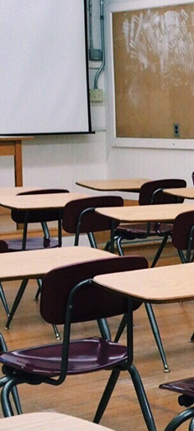
Special Education

Special Education students will attend a full day traditional program when in-school programming returns. The hybrid option may be available to students based on the IEP team recommendations. During 100% distance learning, students will receive services through their case providers online in Zoom sessions.

Special education students who receive Specialized Academic Instruction (SAI) in a Basic (Mild/Moderate) setting will have services delivered to the maximum extent possible in alignment with the student’s IEP through an inclusion program at ILCS.

Designated Instructional Services (DIS) will be provided to the fullest extent possible either in person or online.

14

15

15

Mental Wellness

District and school staff are committed to supporting students’ social emotional wellness and offering resources to ensure students transition back to school smoothly.

Support will include social-emotional learning, building relationships, virtual, and in-person community-building activities, when allowable, and increased access to mental health/wellness services.

Home/School Partnership: Families and schools will need to work together to evaluate how students are feeling and assess their individual needs to provide the support students need during these challenging times.

Full time and part time counselors who are joining student Zoom sessions and holding individual and group counseling online for students and parents throughout the crisis.

16

The California Interscholastic Federation (CIF) Sports Medicine Advisory Committee has developed a comprehensive document to help school districts prepare for their student athletes to return to athletic activities. ILCS will resume athletics adhering to the CIF guidelines in coordination with our league. With guidance from the California Department of Health (CDHP), California Department of Education (CDE), and CIF, ILCS determines the level and duration of each phase for a gradual full physical return to athletics.
Page 9

EXTRACURRICULAR ACTIVITIES

*Field trips are currently suspended. 7th and 8th grade trip to Catalina has been reserved for the Spring of 2021, but will depend on the status of COVID-19 at that time.

ILCS electives, 2nd session classes and other extracurricular activities have been suspended until further notice and may be amended once on-site instruction begins.

17

ADDITIONAL RESOURCES
Page 9

Center for Disease Control (CDC) Guidance for Schools

California Department of Public Health Industry Guidance: Schools and School Based Programs

California Department of Education (CDE) Stronger together: A Guidebook for the reopening for California's Public Schools

San Bernardino County Public Health Department COVID-19 Response Guidance for K-12 Schools

California Interscholastic Federation (CIF) Statement Regarding 2020-21 Sports Calendar and Bylaw Modification

American Academy of Pediatrics COVID-19 Planning Considerations: Guidance for School Re-entry

How to Talk with Children about COVID-19: A Parent Resource

18

What measures should be taken when a student, teacher or staff member has symptoms, is a contact of someone infected, or is diagnosed with COVID-19?

 | Student or Staff with: | Action | Communication
1 | COVID-19 Symptoms (e.g., fever, cough, loss of taste or smell, difficulty breathing) | - Send home  - Recommend testing (If positive, see #3, if negative, see #4)  - School/classroom remain open | No action needed
 | Symptom Screening: Per CA School Sector Specific Guidelines
2 | Close contact (†) with a confirmed COVID-19 case | - Send home  - Quarantine for 14 days from last exposure  - Recommend testing (but will not shorten 14- day quarantine)  - School/classroom remain open | Consider school community notification of a known contact
3 | Confirmed COVID-19 case infection | - Notify the local public health department  - Isolate case and exclude from school for 10 days from symptom onset or test date  - Identify contacts (†), quarantine & exclude exposed contacts (likely entire cohort (††)) for 14 days after the last date the case was present at school while infectious  - Recommend testing of contacts, prioritize symptomatic contacts (but will not shorten 14-day quarantine)  - Disinfection and cleaning of classroom and primary spaces where case spent significant time  - School remains open | School community notification of a known case
4 | Tests negative after symptoms | - May return to school 3 days after symptoms resolve  - School/classroom remain open | Consider school community notification if prior awareness of testing

(†) A contact is defined as a person who is <6 feet from a case for >15 minutes. In some school situations, it may be difficult to determine whether individuals have met this criterion and an entire cohort, classroom, or other group may need to be considered exposed, particularly if people have spent time together indoors.

(††) A cohort is a stable group with fixed membership that stays together for all courses and activities (e.g., lunch, recess, etc.) and avoids contact with other persons or cohorts.
19

San Bernardino County Department of Public Health on Social Media
- Facebook
- Instagram
- Twitter

San Bernardino County Updates
sbcovid19.com (information on COVID-19 and testing opportunities)
San Bernardino County Incidence Rates by School Districts and Cities

Mental Health Resources
SBCDBH: 24 Hour & Emergency Services Division
CDC: Coping with Stress
CDC: Helping Children Cope During COVID-19 Outbreak
CDC: Helping Children Cope with Emergencies
CDC: Coping After a Disaster (Ages 3-10)
CDE: Stronger Together: A Guidebook for the Safe Reopening of California’s Public Schools Mental Health and Well-Being of All (Pages 34-36)
NIH: Teen Depression

Parent/Guardian Resources
CDC: Checklist for Parents

School Resources
- CDC: Checklist for Teachers
- CDC: Reopening Guidance
- CDPH: Guidance for Schools
- CDPH: Schools and School Based Programs Guidance
- CDE: Stronger Together: A Guidebook for the Safe Reopening of California’s Public Schools
- DHS: Guidance on the Essential Critical Infrastructure Workforce
- FDA: Food Safety and the Coronavirus Disease
- OSHA: Guidance on Preparing Workplaces for COVID-19

Centers for Disease Control and Prevention
- CDC: Considerations for Schools

Cleaning and Disinfecting Resources
- CDC: Cleaning and Disinfecting Your Facility
- EPA: Disinfectant for Use Against SARS-CoV-2

U.S. Department of Health & Human Services
  - HSS: HIPAA and COVID-19

Health Promotion Materials
  - CDC: Keeping Hands Clean
  - CDC: Handwashing: A Family Activity

Contact Information

ILCS School Nurse (RN): 909-844-5772

ILCS Health Tech (CSC): 909-446-1100 ext 120
San Bernardino County Contacts
San Bernardino County Response Contacts | Phone Number
Public Health School Liaison (primary contact) | (909) 387-4578
Communicable Disease Section (CDS) | (800) 722-4794
Communicable Disease Section (CDS) After Hours | (909) 677-7168
General COVID-19 Hotline (Monday-Friday 9 a.m. – 5 p.m.) | (909) 387-3911

20
COVID-19 Contact Tracing Process Map for Schools
Individual student gets tested for COVID-19
Medical provider or Lab forwards positive test results to CDS

CDS conducts contact tracing

If potential exposure at school sites is identified through contact tracing, CDS will contact the school’s COVID-19 Response Coordinator to provide guidance and support
Outbreak (multiple positive cases) at school site
School site notifies SBCDPH

SBCDPH works with school’s COVID-19 Response Coordinator to facilitate an outbreak response
A student or staff member at the school displays symptoms
or has a positive diagnosis
Relocate potentially exposed students and staff to a predetermined isolated area on campus

Contact the parents of those potentially exposed

Send potentially exposed students/staff home. Conduct contract tracing to identify and inform potential exposures

Communicate the potential exposure and precautions being taken to stakeholders, while preserving confidentiality

Inform those with a confirmed exposure to isolate at home for 14 days and advise to be
tested. Distance learning may be arranged for students

An HR representative should reach out to any impacted employees regarding leave considerations

Disinfect areas of confirmed exposure

21

